Kolbe Catholic College

Year 8 Science - 2022

**Task 1 – Energy Topic Test (M)**

Name: _____**Answers**________________

Answer the following questions in the space provided.

Total: /42 %

**MULTIPLE CHOICE 9 Marks**

**Use a pencil and erase incorrect answers completely.**

1. An object that is moving from point A and point has:
   1. Electrical energy
   2. Chemical energy
   3. Kinetic energy
2. Which of the following is not a type of potential (stored) energy?
   1. Gravitational energy (an object held above the ground)
   2. Sound energy (a radio playing)
   3. Chemical energy (a battery waiting to be used)
3. Which of the following statements about energy is CORRECT?
   1. Energy has many different forms, including heat, kinetic and light.
   2. Energy is something that can be created whenever we want.
   3. If something has energy it has to be moving, for example a train speeding along
4. Which of the following is an example of an object INCREASING in energy?
5. A car engine: while it is cooling down after a long drive
6. A ball: moving faster and faster as it rolls down a hill
7. A sprinter: coming to a stop after the finish line

1. The scientific unit of energy is the:
   1. Joule (J)
   2. Volt (V)
   3. Degrees Celcius (°C)

a)

b)

c)

1. Which of the devices pictured above carries out this energy transformation?

(input) Light 🡪 (output) electricity

1. Wind turbine
2. Torch
3. Solar panel
4. The direction that heat flows is always:
   1. From the cold object to the hot object
   2. From both objects – does not matter which object has more or less heat
   3. From the hot object to the cold object
5. Craig watches a music video clip on his plasma screen TV.

Choose the best description of the energy transformations that are   
 happening.

1. sound energy + light energy + heat energy 🡪 electrical energy
2. electrical energy 🡪 sound energy + light energy + heat energy
3. sound energy + light energy 🡪 electrical energy
4. The Earth gets most of its energy from
5. plants
6. the Sun
7. batteries

**SHORT ANSWER QUESTIONS 33 Marks**

**Write your answers in the space provided.**

1. This diagram shows a solar cell that is used to operate a solar fan.

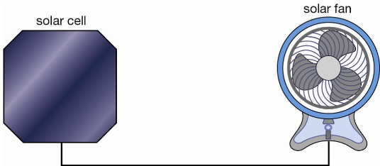

output 🡪 kinetic + sound   
 energy

Input 🡪 Light energy

Draw an energy flow diagram to show the energy changes that take place in this process. (2 marks)

Light energy 🡪 electrical energy 🡪 kinetic energy + sound energy

(0.5). (0.5) (0.5) (0.5)

1. The faster an object moves, the greater the kinetic energy it has.

Circle which object has greatest kinetic energy in each question below:   
 (3 marks)

1. a person walking OR a person riding a bike
2. a speed boat OR a sailing boat
3. a jet plane OR a paper plane
4. Fill in the missing words choosing from the word bank below. (2 marks)

The Law of Conservation of Energy states:

“Energy can neither be **created ( ½ )** nor **destroyed ( ½ )**, it can only be transformed or transferred from one form to another. “

|  |  |  |  |
| --- | --- | --- | --- |
| destroyed | wasted | created | useful |

1. The Law of Conservation of Energy means that the input energy into a system must always equal the total output energy.   
   **Calculate the missing energy values in the examples below.** The first one has been completed for you. (3 marks)

Kinetic Energy: 7500 J

Light Energy: 360 J

**+**

**+**

Sound Energy= 2500 J

Electrical Energy: 10,000 J

Electrical Energy: 3600 J



Heat Energy: 3240 J



**Electrical Energy: 3600J**

Kinetic Energy: 10,500 J

Kinetic Energy: 3700 J

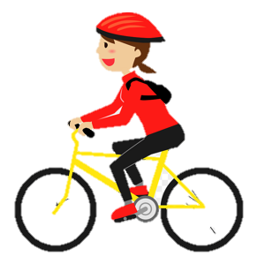

Chemical Energy: 13,500 J

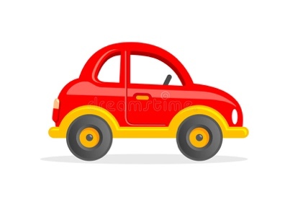

**+**

Chemical Energy: 9000 J

**+**

Sound Energy: 2,500 J

Heat Energy: 5300 J

**+**

Heat Energy:   
500 J

1. Read the following descriptions below and determine whether an **energy transfer** or **energy transformation** best describes the effect that has taken place. (4 marks)
2. The wind moving clothes hanging on a washing line. **transfer**
3. An iPad screen lighting up after being turned on. **transformation**
4. A muscle cell contracting when a bicep is flexed. **transformation**
5. A foot kicking a stationary ball. **transfer**.
6. For each of the following systems, identify the input energy, useful output energy and one form of wasted energy. Two answers have already been completed for you. (2 marks)

*kinetic chemical potential sound heat light*

|  |  |  |  |
| --- | --- | --- | --- |
| **System** | **Input** | **Useful** | **Wasted** |
| Torch | Chemical | Light | Heat |
| Electric Beater | Electrical | Kinetic | Sound / Heat |

1. Identify the following examples of heat transfer as either **conduction** or **convection**. (4 marks)

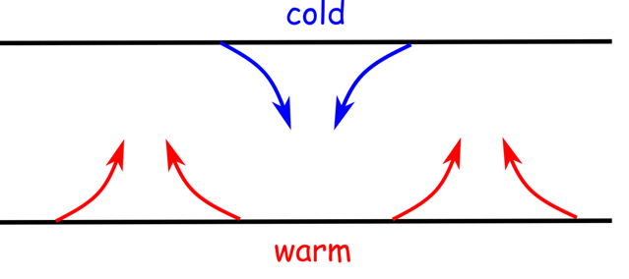

CONVECTION CONDUCTION

|  |  |
| --- | --- |
| **Example** | **Conduction or Convection** |
| Your throat warming from drinking hot chocolate. | **Conduction** |
| Boiling water in a saucepan on the stove. | **Convection** |
| An air-conditioner in a room causing the hot air to rise. | **Convection** |
| Your hands feeling cold holding a can of soft drink straight from the fridge. | **Conduction** |

1. Name the method of heat transfer from the Sun to the Earth.   
    (1 mark)

**Radiation**

1. 200 mL of cold water is heated in a spotted saucepan, and 400 mL of cold water is heated in an identical striped saucepan.

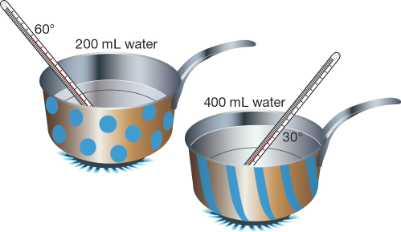

Each of the saucepan’s handles are made of a thick, tough plastic. Explain why they would be made of plastic and not metal. (2 marks)

|  |
| --- |
|  |
| Metal handle would get hot |
| Plastic is an insulator/protects hands from heat |

1. A student switches a kettle on to heat up some water for an experiment. She hears a loud noise as the kettle boils due to the water bubbling. The **total input energy** into the kettle is **5000 J.** The **useful output energy** of heat is 3500J. The **wasted output energy** of sound is 1500 J. Using the formula below, calculate the energy efficiency of the kettle.

*Show your working* *out* (2 marks)

1. Fill in the blanks in the following passage using the word bank below.   
    (3 marks)

Heat is the transfer of __energy___. During energy transfer, the energy moves from the __hotter_ object to the ___colder__ object. This means that the hotter object will cool down and the colder object will warm up.

When heat energy is transferred to an object, the energy of the particles ___increases__. This means the particles have more __kinetic__ energy and they start to move and vibrate _faster_____.

radiation faster increases colder

energy medium kinetic hotter

1. Draw a line between words below and their meaning. (5 marks)

|  |  |  |
| --- | --- | --- |
| Temperature |  | Caused by vibration of particles |
| Sound Energy |  | Stored Energy |
| Heat Energy |  | How hot or cold something is |
| Potential Energy |  | Energy of Movement |
| Kinetic Energy |  | Thermal energy |

**End of Test**